NAME: GABRIEL UGONNA JUDITH
DATE: 20TH JUNE, 2026.
PROJECT TITLE: TELECOMMUNICATION ANALYSIS.

TABLE OF CONTENT:
- INTRODUCTION ---------------------------------------------------------------------------------PAGE 3
2. OBJECTIVES
3. DATA OVERVIEW -------------------------------------------------------------------------------PAGE 3
4. DATA CLEANING STEPS --------------------------------------------------------------------PAGE 3 & 4
5. KPI EXPLANATION -----------------------------------------------------------------------------------PAGE 4 & 5
6. EXPLORATORY DATA ANALYSIS (EDA)--------------------------------------------PAGE 5, 6, 7 & 8
7.1 Question 1 — What subscription plan generates the most revenue?
8.2 Question 2 — What customer segment has the highest Churn rate?
9.3 Question 3 — What factors are associated with customer churn?
7. RECOMMENDATION ---------------------------------------------------------------------PAGE 8 & 9
8. DASHBOARD-------------------------------------------------------------------------------------PAGE 10
9 CONCLUSION---------------------------------------------------------------------------------PAGE 10
10. REFERENCES ---------------------------------------------------------------------------------PAGE 10.

INTRODUCTION:
This dashboard presents an analysis of customer churn and retention within the telecommunications dataset, covering key metrics such as churn rate, retention rate, revenue impact, customer satisfaction (NPS), and usage behavior across various customer segments including plan type, region, age group, gender, and device type.

OBJECTIVES:
- To determine which subscription plan type generates the highest revenue, in order to identify the most profitable product offerings.
- To identify the customer segment(s) with the highest churn rate, in order to pinpoint the specific groups most at risk of attrition.
- To examine the key factors associated with customer churn, in order to understand the underlying drivers of customer attrition and inform targeted retention strategies.

DATA OVERVIEW:
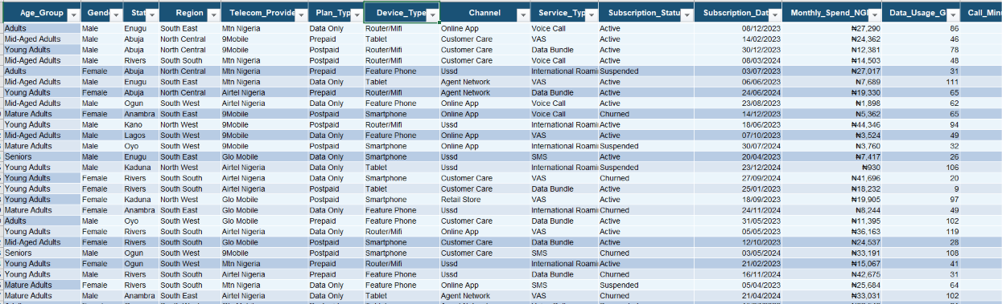
Cleaned Dataset.
DATA CLEANING STEPS:
- The following steps were undertaken to clean and prepare the dataset for analysis:
- Removed 12 duplicate records to ensure data accuracy and prevent inflated counts.
- Sorted the Customer ID column in ascending (A–Z) order for easier reference and organization.
- Categorized the Age Group column into descriptive labels for improved readability: 18–24 as Young Adults, 25–34 as adults, 35–44 as Mid-Aged Adults, 45–54 as Mature Adults, and 55+ as Seniors.
- Standardized the Gender column using the TRIM and PROPER functions to remove extra spaces and correct text casing.
- Standardized the State, Region, Telecom Provider, Plan Type, Device Type, and Channel columns using the TRIM and PROPER functions to ensure consistent formatting.
- Formatted the Date column using Short Date format; where dates were incorrectly stored as text, the Text-to-Columns feature was used to convert them into proper date values.
- Formatted the Monthly Spend column as currency with the Naira (₦) symbol, and applied the ABS function to correct negative values.
- Removed decimal points from the Data Usage column for cleaner, whole-number reporting.
- Created a new Net Promoter Status column, categorizing NPS scores into Detractor, Passive, and Promoter groups.
- Standardized the Complaint Category and Data Bundle Type columns using the TRIM and PROPER functions to ensure consistent capitalization and formatting.
- Standardized the Recharge Frequency column using the TRIM and PROPER functions, and used Find and Replace to correct inconsistent entries (e.g., changing "2-3x/weekly" to "2–3 Times Per Week").

KPI EXPLANATION:
AVERAGE CUSTOMER TENURE
RETENTION RATE
REVENUE LOST TO CHURN
TOTAL REVENUE MONTHLY SPEND
TOTAL CUSTOMERS
62%
₦2.0M
25.2
₦11.4M
520

TOTAL CUSTOMERS: The total number of unique customers in the dataset.
TOTAL REVENUE MONTHLY SPEND: The sum of all customers monthly spends, representing the total revenue generated in a given month.
AVERAGE CUSTOMER TENURE: The average length of time (in months) that customers have stayed with the telecom provider.
REVENUE LOST TO CHURN: The total monthly revenue associated with customers who have churned (cancelled/left).
RETENTION RATE: The percentage of customers who remain active (have not churned) out of the total customer base.

EXPLORATORY DATA ANALYSIS (EDA):
WHAT SUBSCRIPTION PLAN GENERATES THE MOST REVENUE:
REVENUE BY PLAN TYPE

Postpaid generates the highest revenue at ₦4,276,281M, followed by Data Only at ₦3,802,056M, and prepaid at ₦3,313,945M. Postpaid leads the total revenue ranking, though the gap between all three plans is relatively narrow.
Postpaid customers are the most valuable segment in terms of total revenue contribution, likely reflecting either a larger customer base on this plan or higher individual spending (or both). The close performance of Data Only at ₦3,802,056M is notable — it suggests strong demand for data-centric plans and may indicate an opportunity to grow this segment further. Prepaid, despite often having the highest customer volume in telecom generally, contributes the least revenue here, which could point to lower average spend per prepaid customer.

WHICH CUSTOMER SEGMENT HAS THE HIGHEST CHURN RATE:
CHURN RATE BY AGE GROUP

Matured Adults have the highest churn rate at 27.03%, followed by adults at 23.75%, while Mid-Aged Adults have the lowest churn rate at 19.39%.
This suggests Mature Adults customers are more price-sensitive or more likely to switch providers, possibly due to promotional offers from competitors or lower brand loyalty.
This is unexpected, since older, established customers are usually more loyal. It suggests this group may be dissatisfied with pricing, service quality, or their current plan and losing them likely costs more, since they tend to be higher-spending customers.

WHAT FACTORS ARE ASSOCIATED WITH CUSTOMERS CHURN:
CHURN RATE BY COMPLAINT CATEGORY

Customers who complained about Poor Coverage have the highest churn rate at 28.33% among all complaint categories.
This points to a network infrastructure problem, not a service or billing issue — customers are leaving because the product itself (signal/network access) isn't reliably meeting their needs. Unlike complaints about pricing or customer service, poor coverage is harder for the customer to tolerate or work around, making it a stronger, more urgent churn driver.
AVERAGE TENURE BY SUBSCRIPTION

Churned customers have the highest average tenure at 26.8 months — higher than both Active and Suspended customers.
This is a significant and somewhat counterintuitive finding; customers aren't leaving early; they're actually leaving after a long relationship with the company. This shifts the story away from an "onboarding problem" and toward a loyalty fatigue or value erosion issue — long-term customers may feel taken for granted, may not be getting rewarded for their loyalty (no upgrade offers, discounts, or recognition), or may eventually get pulled away by a competitor's offer after years of paying full price. It could also mean their needs have evolved over time and their current plan no longer fits them.
CHURN RATE BY NPS STATUS

Customers classified as Passive on the Net Promoter Score have the highest churn rate at 28.74% — higher than both Detractors at 21.49% and Promoters at 17.81%.
To understand why this matters, it helps to first understand what "Passive" actually means. NPS groups customers into three types:
- Promoters — genuinely happy, loyal customers who'd recommend the service
- Detractors — unhappy customers who are likely to complain or speak negatively about the service
- Passives — customers who are "okay" with the service. Not impressed, not upset. They stay because it's convenient, not because they're loyal.
Normally, businesses assume Detractors are the biggest churn risk, because they're the ones complaining and clearly signaling dissatisfaction. But this data shows the opposite: Passives churn more than Detractors.
This is an important and often overlooked finding — Passives are neither loyal advocates nor openly dissatisfied, which normally makes them "safe" or overlooked in retention efforts. But this data shows they're actually the most likely to quietly leave. Unlike Detractors, who at least signal dissatisfaction through complaints (giving the business a chance to intervene), Passives churn silently — they simply don't feel strongly enough about the service to stay when a better or cheaper alternative appears.

RECOMMENDATION:
Question 1:
- Protect and grow the Postpaid segment — since it generates the highest revenue (₦4.0M), prioritize retention efforts here (loyalty perks, dedicated support) to prevent losing high-value customers.
- Invest further in Data Only plans — its close performance (₦3.8M) signals strong demand for data-centric offerings; consider expanding data bundle options or promotions to grow this segment further.
- Review Prepaid pricing/value proposition — since it generates the least revenue (₦3.3M) despite often having high subscriber volume, investigate whether pricing, bundle value, or upgrade incentives could increase average spend per Prepaid customer.

Question 2:
- Launch a targeted loyalty program for long-tenure customers: since churned customers had the highest average tenure (26.8 months), the business should proactively reward and re-engage customers as they approach the 2-year mark, before value/loyalty fatigue sets in.
- Prioritize retention campaigns for Mature Adults (45–54): as the highest-churning age group, they should receive personalized plan reviews, loyalty discounts, or proactive service check-ins rather than generic offers.
- Introduce periodic "renewal moments": e.g., anniversary offers, loyalty upgrades, or check-in calls at key tenure milestones (12, 18, 24 months) to reinforce value before customers disengage.

Question 3:
- Invest in network coverage improvement: since "Poor Coverage" is the top complaint category linked to churn, this is a product/infrastructure issue, not a service one; prioritize coverage expansion or signal improvement in the most affected regions.
- Build a proactive engagement strategy for Passive NPS customers: since Passives churn the most (28.74%) but never complain, the business needs regular check-ins, small loyalty nudges, or usage-monitoring alerts to catch this "silent risk" group before they leave — rather than relying only on complaint-driven retention efforts.
- Shift from reactive to proactive retention: overall, the data shows the biggest churn risks (Passives, long-tenure customers, coverage issues) don't announce themselves through complaints. The business should move beyond "fix what's complained about" toward monitoring usage patterns, tenure milestones, and NPS trends to catch at-risk customers earlier.

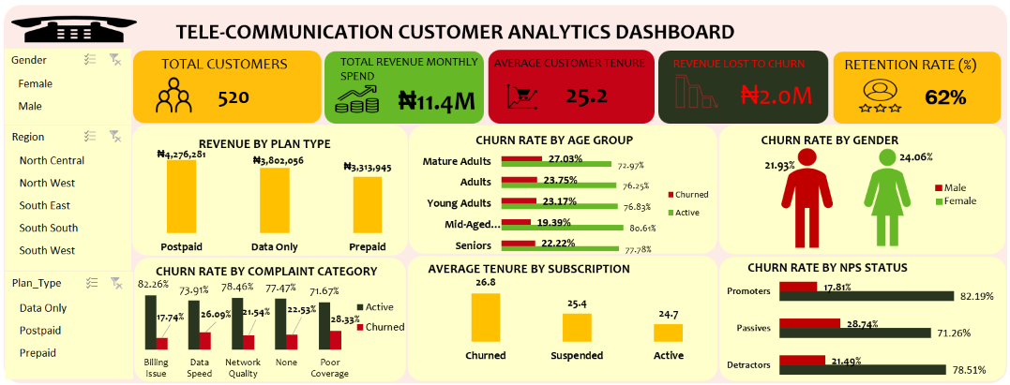

CONCLUSION:
This analysis set out to answer three key business questions: which subscription plan generates the most revenue, which customer segment has the highest churn rate, and what factors are associated with customer churn. The findings revealed that Postpaid is the leading revenue-generating plan, though Data Only plans show strong potential for growth. Contrary to typical assumptions, churn was found to be highest among long-tenured customers (26.8 months average) and Mature Adults (45–54), suggesting that loyalty erodes over time rather than churn being an early-life problem. Additionally, Poor Coverage emerged as the leading complaint category linked to churn, pointing to a network infrastructure issue, while Passive NPS customers despite showing no visible dissatisfaction recorded the highest churn rate, revealing a "silent risk" segment that traditional complaint-driven retention strategies fail to capture.
Overall, churn in this dataset isn't mainly caused by new or unhappy customers who complain, it's driven by long-term customers who quietly leave without warning. This means retention efforts should shift from just reacting to complaints, to actively watching for warning signs like customer tenure, NPS scores, and usage patterns. Improving network coverage and rewarding long-term customers are the two most important actions the business can take to reduce churn and protect revenue.

REFERENCES:
The tool/software used is Microsoft Excel.

